Stow Cum Quy Fen pond survey

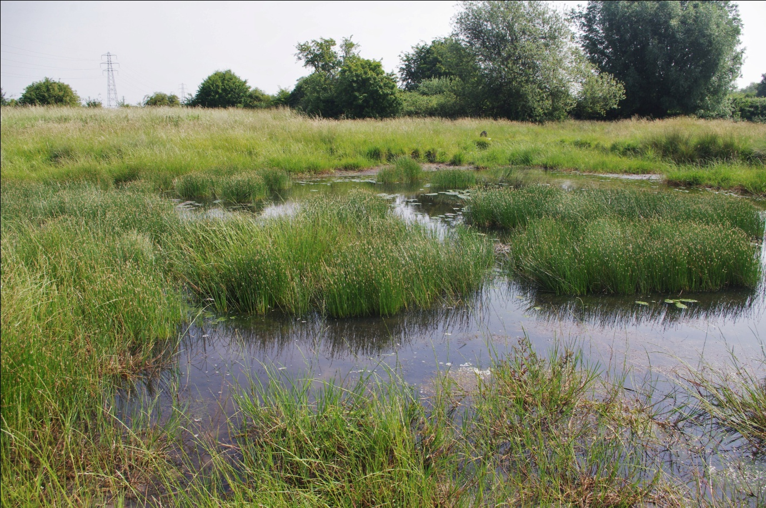

A report for the Freshwater Habitats Trust
July 2017
(Version 2)
1. Introduction
Stow-cum-Quy Fen Site of Special Scientific Interest (SSSI) covers 29.6 hectares and is located 7.5 km north-east of the centre of Cambridge. It features a number of ponds, the largest being a coprolite pit from which phosphate-rich deposits were excavated in the mid to late 19th century for fertiliser (O’Connor, 2001 & 2011). Originally believed to be fossilised dinosaur dung, the ‘coprolite’ seams were in fact phosphatic nodules derived from the remains of marine molluscs, cephalopods and other organisms deposited during the Jurassic (Cambridgeshire Archaeology Field Group, 2015). The elongate shape of some smaller ponds suggests that these too originated as coprolite pits but others are likely to be stock watering ponds.
This survey was commissioned by the Freshwater Habitats Trust as part of the Flagship Ponds project. Fieldwork for was undertaken by Jonathan Graham (botanical survey) and Martin Hammond (invertebrates) on 17th May 2017. This was followed by a second visit on 21st June 2017 to seek out additional species.
2. Survey methods
Eight ponds (refer to location map below) were surveyed using PSYM (Predictive System for Multimetrics), the standard methodology for evaluating the ecological quality of ponds and small lakes (Environment Agency, 2002). A PSYM survey involves:
- Obtaining environmental data such as pond area, altitude, grid reference, substrate composition, cover of emergent vegetation, degree of shade, accessibility to livestock and water pH
- Collecting a sample of aquatic macro-invertebrates using a standard protocol (three minutes’ netting divided equally between each ‘meso-habitat’ within the pond basin, plus one minute searching the water surface and submerged debris)
- Recording wetland plants
PSYM generates six ‘metrics’ (measurements) representing important indicators of ecological quality. The three botanical metrics are:
- diversity of emergent and submerged plant species
- the number of uncommon plant species
- Trophic Ranking Score (TRS, an estimation of nutrient status based on plant indicators)
The three invertebrate metrics are:
- Average Score Per Taxon (ASPT, an estimation of biological water quality based on the sensitivity of different invertebrate families to organic enrichment)
- diversity of dragonfly, damselfly and alderfly families
- diversity of water beetle families
The results are analysed using software which compares the observed data with values predicted from a large reference dataset of undegraded ponds. PSYM predicts how a high quality pond with similar attributes should score for each metric, and compares the predictions with the survey results. The scores for each metric are combined to produce an Index of Biotic Integrity (IBI) which provides an overall indication of the ecological quality of the pond. Ponds are then categorised as Very Poor, Poor, Medium and Good.
Whilst PSYM requires only family-level identification of invertebrates, material was identified to species level wherever possible. As a departure from normal procedure, the sample was sorted on the bankside to avoid the risk of removing large numbers of individuals of rare species.
In order to record larger dytiscid beetles (which often elude capture by hand-netting), baited bottle traps were placed in several of the ponds the evening before the survey. Details of captures are given on the accompanying spreadsheet. Bottle trap captures did not form part of the PSYM samples.
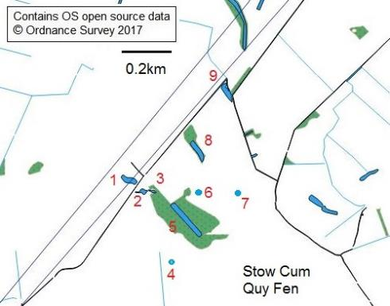
Location map for ponds surveyed
On 21st June, Ponds 1, 2, 3, 5 and 6 were re-examined to search for additional species

3. The ponds surveyed
Pond 1
Grid reference | TL 51122 62848
Size | 1634 m²
pH | 7.3
Conductivity (µS/cm­¹) | 1070
% shading | 30
% emergent | 20
Substrate | Clay/silt
Grazing | Ungrazed

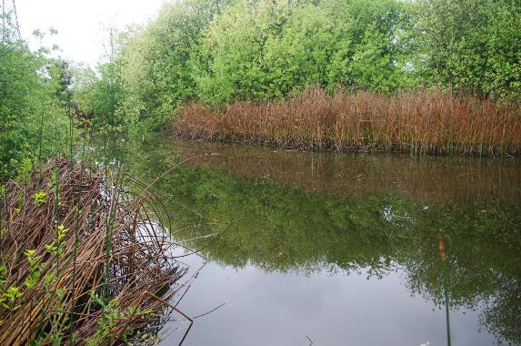
A partly shaded pond with dense marginal willow scrub. Its elongate shape suggests it may have originated as a coprolite pit. The northern and eastern margins support Common Reed Phragmites australis fringe while the southern margin has stands of Common Club-rush Schoeneoplectus lacustris. A few other emergent species are present in small quantity including False Fox-sedge Carex otrubae, Greater Willowherb Epilobium hirsutum, Blunt-fruited Rush Juncus subnodulosus, Gipsywort Lycopus europaeus, Purple Loosestrife Lythrum salicaria, Water Mint Mentha aquatica, Amphibious Bistort Persicaria amphibia, Clustered Dock Rumex conglomeratus and Woody Nightshade Solanum dulcamara. There are no submerged aquatics and the bed is dominated by filamentous algae (Spirogyra sp.) Exposed logs, marginal willow trunks and roots are colonised by Kneiff’s Feather-moss Leptodictyum riparium and Greater Water-moss Fontinalis antipyretica was noted from a single willow trunk (N side of pond at the water’s edge).
This pond yielded 46 aquatic macro-invertebrate taxa (40 from the PSYM sample). These included two Near Threatened water beetles (Enochrus nigritus and Limnebius papposus) along with a few local species such as Hairy Dragonfly Brachytron pratense and the scavenger water beetle Cercyon sternalis.
Moorhen, Sedge Warbler and Common Toad tadpoles were observed. Three-spined Sticklebacks were abundant.
Evaluation using PSYM gave Pond 1 an Index of Biotic Integrity (IBI) of 72%, placing it at the top end of the Moderate category for ecological quality, just below the 75% threshold for Good quality. It scored poorly for diversity of submerged and emergent plants, and for representation of uncommon species but Trophic Ranking Score (TRS) was favourable. Scores for biological water quality (ASPT) and diversity of water beetle families were high but representation of Odonata families was only moderate.
Pond 2
Grid reference | TL 51207 62797
Size | 600 m²
pH | 7.6
Conductivity (µS/cm­¹) | 690
% shading | 0
% emergent | 20
Substrate | Clay/silt
Grazing | Accessible to livestock

This is an open, cattle-grazed pond with grass mats and mixed low emergent vegetation in the shallows. In the open water, submerged vegetation features Nuttall’s Waterweed Elodea nuttallii, Horned Pondweed Zannichellia palustris and stoneworts. The latter comprised the Nationally Scarce Clustered Stonewort Tolypella glomerata in addition to Common Stonewort Chara vulgaris and Bristly Stonewort C. hispida. Twenty-eight wetland plant species were recorded with other noteworthy species including Water Violet Hottonia palustris (categorised as Vulnerable in England), Orange Foxtail Alopecurus aequalis and Brookweed Samolus valerandi.
Fifty-eight aquatic taxa were identified (51 from the PSYM sample). These included three Nationally Scarce species: the algivorous water beetle Peltodytes caesus (which was plentiful on both visits), the scavenger water beetle Enochrus quadripunctatus and the Pink Water-speedwell Weevil Gymnetron villosulum. Local species included Hairy Dragonfly, the water-singer Micronecta scholtzii and the scavenger water beetle Cercyon sternalis.

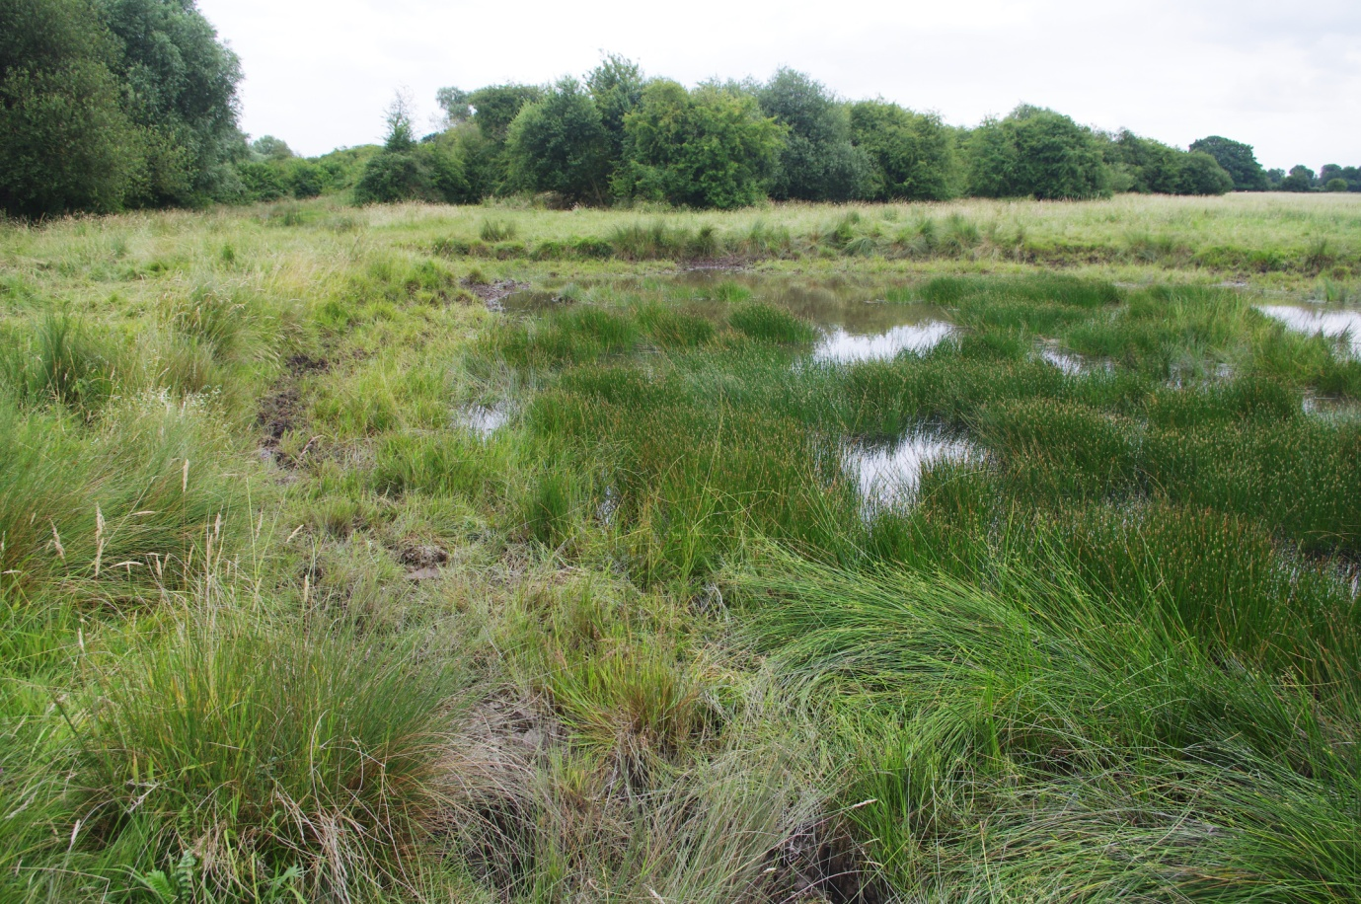
Three soldierfly taxa were collected as larvae: the widespread but local Common Green Colonel Oplodontha viridula, and two Oxycera species. The latter included one species with indented posterior corners to the final abdominal segment and another without.
Common Frog and Common Toad tapoles were noted along with Nine-spined Sticklebacks.
Evaluation using PSYM gave Pond 2 an Index of Biotic Integrity (IBI) of 94%, placing it in the top (Good) category for ecological quality. It scored highly for diversity of submerged and emergent plants, and for representation of uncommon species. Indeed for both of these metrics, the pond scored much better than the model predicted. Trophic Ranking Score (TRS) was moderate, suggesting that the flora was more indicative of high nutrient status than expected for an undegraded pond with similar characteristics. Pond 2 scored well for all three invertebrate metrics.
Pond 3
Grid reference | TL 51251 62795
Size | 240 m²
pH | 7.3
Conductivity (µS/cm­¹) | 670
% shading | 2
% emergent | 65
Substrate | Clay/silt
Grazing | Accessible to stock

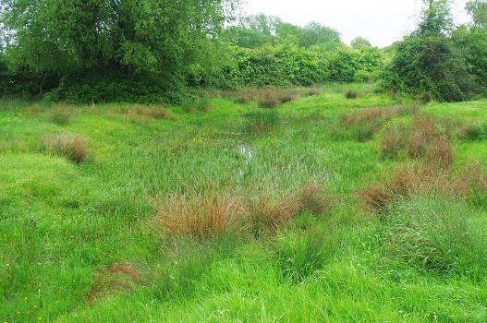
This pond forms an eastwards extension of Pond 2 but is separated by a track; it merges into a shallow, seasonal drain. Twenty-eight wetland plant species include three which are categorised as Vulnerable in England: Lesser Water-plantain Baldellia ranunculoides, Water Violet and Lesser Spearwort Ranunculus flammula. Also of note are Marsh Pennywort Hydrocotyle vulgaris (listed as Near Threatened in England), Orange Foxtail, Bristly Stonewort and Brookweed.
This pond yielded 54 aquatic macro-invertebrate taxa (42 in the PSYM sample). These included two Near Threatened water beetles (Enochrus nigritus and Limnebius papposus) along with the Nationally Scarce beetles: the hydrophilid Enochrus quadripunctatus and the aquatic weevil Pelenomus canaliculatus. Also of note were the scavenger water beetle Hydrobius rottenbergii, the Pink Water-speedwell Weevil Gymnetron villosulum and the Black Colonel soldierfly Odontomyia tigrina.
Evaluation using PSYM gave Pond 3 an Index of Biotic Integrity (IBI) of 94%, placing it in the top (Good) category for ecological quality. It scored highly for all three botanical metrics. It scored well for biological water quality (ASPT) and diversity of water beetle families, though only moderately for diversity of Odonata families.
Pond 4
Grid reference | TL 51342 62492
Size | 320 m²
pH | 8.4
Conductivity (µS/cm­¹) | 460
% shading | 0
% emergent | 0
Substrate | Clay/marl
Grazing | Ungrazed (fenced)

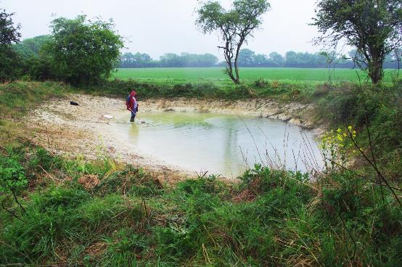
This newly-excavated pond has been created in a fenced off enclosure on the boundary of the Fen, with arable land to the south. It has an exposed chalk-marl substrate. Pioneer vegetation is dominated by Common Stonewort, Bristly Stonewort and the scarce Clustered Stonewort. Small numbers of Common Frog and Common Toad tadpoles were present.
The PSYM sample included invertebrate 21 taxa. Prominent amongst these were pioneer species such as the diving beetles Agabus nebulosus, Hygrotus confluens and Hydroglyphus geminus and the lesser water-boatman Sigara lateralis. The scavenger water beetle Berosus affinis, a local but apparently increasing species of shallow ponds with exposed clay substrates, was abundant.
Evaluation using PSYM gave Pond 4 an Index of Biotic Integrity (IBI) of 78%, placing it in the top (Good) category for ecological quality. Diversity of submerged and emergent plants was very poor but representation of uncommon species and Trophic Ranking Score were good. This was expected as the pond is only recently created and supports pioneer stonewort vegetation. Pond 4 scored well for biological water quality (ASPT) and diversity of water beetle families, though only moderately for diversity of Odonata families.
Pond 5
Grid reference | TL5140262668
Size | 3700 m²
pH | 7.6
Conductivity (µS/cm­¹) | 900
% shading | 5
% emergent | 15
Substrate | Marl/ gravel
Grazing | 50% grazing (E margin), partly fenced

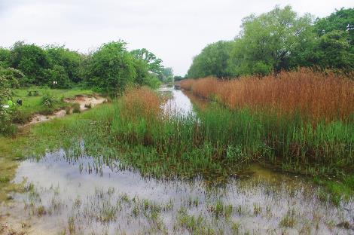
This is the main coprolite pit: it is the largest and most botanically diverse water body at Stow-cum-Quy Fen.
Forty-nine wetland plant species were recorded including the Nationally Scarce Fringed Water-lily Nymphoides peltata. Tufted Sedge and Marsh Pennywort are categorised as Near Threatened in England whilst Lesser Water-plantain, Water Violet and Lesser Spearwort are listed as Vulnerable. Also of note are Narrow-leaved Water-plantain Alisma lanceolatum, Flowering Rush Butomus umbellatus, Soft Hornwort Ceratophyllum submersum and Bristly Stonewort.
Sixty aquatic invertebrate taxa were recorded (44 in the PSYM sample). These included, on 21st June, the Red List (Vulnerable) reed-beetle Donacia sparganii and the Nationally Scarce Pink Water-speedwell Weevil Gymnetron villosulum. In addition, local insects included Hairy Dragonfly (amongst nine larval Odonata species), Water Stick-insect Ranatra linearis, the water singer Micronecta scholtzii, the Pondweed Bug Mesovelia furcata and the great diving beetles Dytiscus circumflexus and D. semisulcatus.
Evaluation using PSYM gave an Index of Biotic Integrity (IBI) of 100%, placing Pond 5 in the top (Good) category for ecological quality. It achieved the maximum score for all six metrics, meaning that it met or exceeded predictions for all measures of ecological quality.

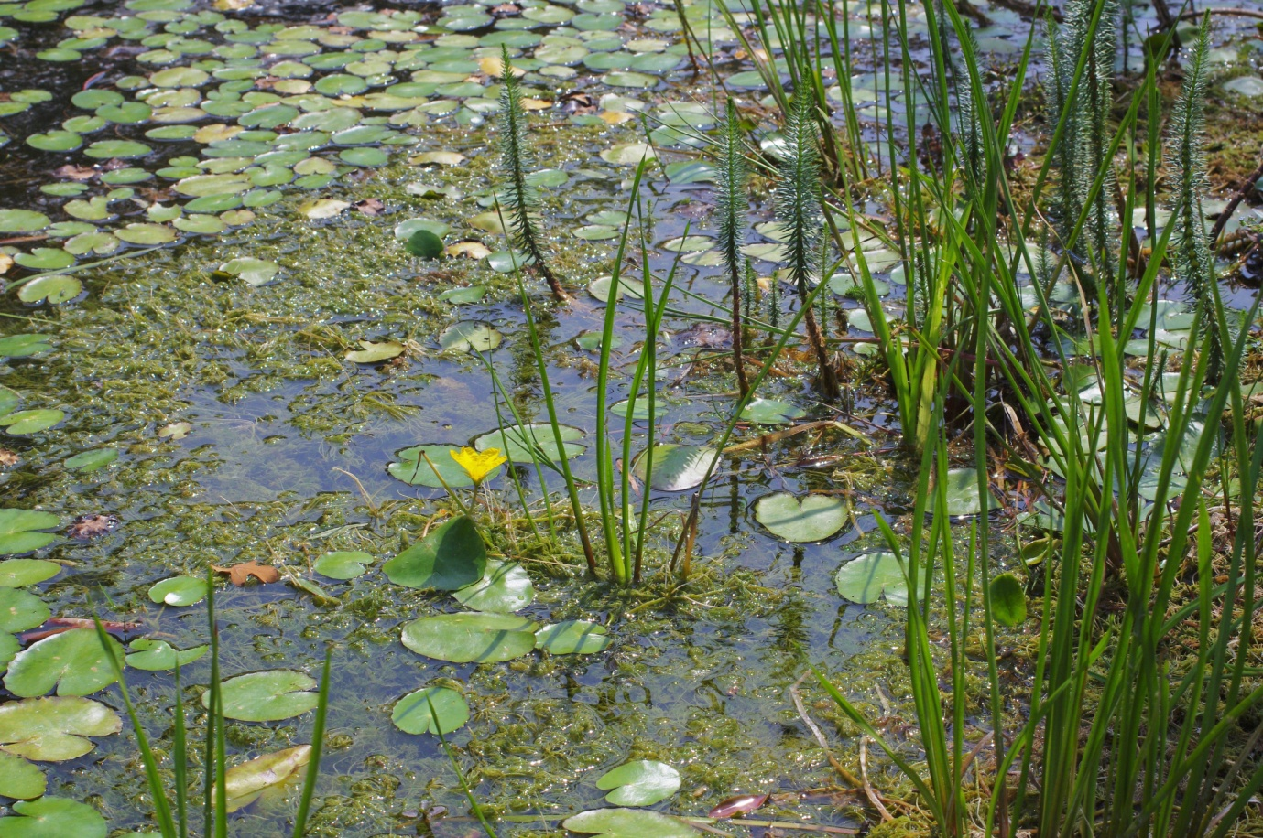
Fringed Water-lily, Flowering Rush, Mare’s-tail and mixtures of the stoneworts Chara hispida and C. vulgaris in Pond 5
Pond 6
Grid reference | TL 51477 62754
Size | 230 m²
pH | 7.9
Conductivity (µS/cm­¹) | 1020
% shading | 15
% emergent | 10
Substrate | Silt
Grazing | No grazing (fenced)

This permanent pond supports submerged beds of Soft Hornwort Ceratophyllum submersum and has a broad belt of mossy vegetation in the draw-down zone. It is fenced off from livestock. Twenty wetland plant species were recorded. Fifty aquatic macro-invertebrate taxa were recorded (42 in the PSYM sample). These included the Near Threatened scavenger water beetle Enochrus nigritus and the Nationally Scarce aquatic weevil Pelenomus canaliculatus.
Evaluation using PSYM produced an Index of Biotic Integrity of 94%, placing Pond 6 in the top (Good) category for ecological quality. It scored highly for all metrics apart from diversity of Odonata families, which was moderate.
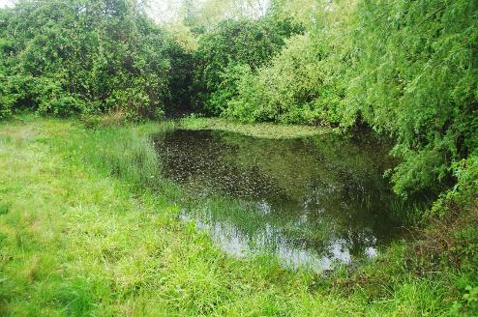
Pond 7
Grid reference | TL 51646 62779
Size | 360 m²
pH | 7.9
Conductivity (µS/cm­¹) | 810
% shading | 10
% emergent | 17
Substrate | Silt
Grazing | No grazing (fenced)

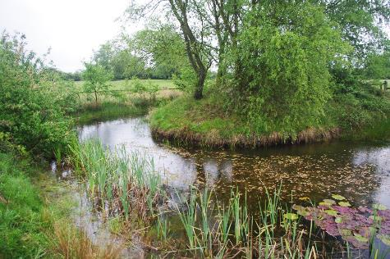
This pond is also fenced-off to exclude livestock. It has submerged stonewort beds, a small stand of Fen Pondweed Potamogeton coloratus and more extensive growth of Broad-leaved Pondweed P. natans. Twenty-eight wetland plant species were recorded, Fen Pondweed being categorised as Nationally Scarce. Also of note are Lesser Spearwort and Meadow-rue Thalictrum flavum. The water-lily Nymphaea marliacea has been introduced.
Thirty-four aquatic macro-invertebrate taxa were identified from the PSYM sample. None of these are species of national conservation concern but local species included Hairy Dragonfly, the stonewort-feeding beetle Haliplus obliquus and the scavenger water beetle Hydrobius subrotundus. Purple Loostrife Leaf-beetle Galerucella calmariensis was present on its host plant on the pond banks.
A Water Vole was seen and grazing lawns and burrows observed.
Evaluation using PSYM gave an Index of Biotic Integrity (IBI) of 100%, placing Pond 7 in the top (Good) category for ecological quality. It achieved the maximum score for all six metrics, meaning that it met or exceeded predictions for all measures of ecological quality.

Pond 8
Grid reference | TL 51451 62990
Size | 1902 m²
pH | 7.6
Conductivity (µS/cm­¹) | 930
% shading | 70
% emergent | 30
Substrate | Silt
Grazing | No grazing (fenced)

This is a coprolite pit now surrounded by trees at the eastern edge of the Fen. It supports extensive cover of Common Reed with sprawling vines of Woody Nightshade but Kneiff’s Feather-moss was the only other wetland plant recorded. Only nine aquatic macro-invertebrate taxa were recorded, the great diving beetle Dytiscus circumflexus (bottle-trapped) being the only uncommon species.
Evaluation using PSYM produced an IBI of 33%, placing Pond 8 in the Poor category for ecological quality. Diversity of submerged and emergent plants was very poor with a null score for representation of uncommon species. Trophic Ranking Score was good but since this was based on only two species the metric means little. Biological water quality was moderate and diversity of water beetle families poor, with a null score for Odonata.

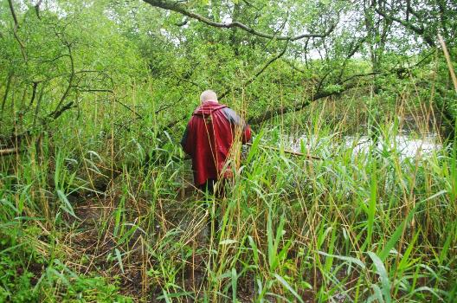
Pond 9
Grid reference | TL 51598 63245
Size | 1500 m²
pH | 7.5
Conductivity (µS/cm­¹) | 1030
% shading | 90
% emergent | 80
Substrate | Silt
Grazing | No grazing (fenced)

This water body is connected to Commissioners’ Drain and has a throughput of moving water. Deep, unstable silt made it too hazardous to sample invertebrates properly, so it was not assessed using PSYM. Seven wetland plants were recorded, none of which are species of conservation concern.

4. Results
4.1 Physico-chemical status
All water samples indicated near-neutral to moderately alkaline water chemistry, with a pH range of 7.3 to 8.4 and a mean reading of 7.68.
Electrical conductivity (a measure of solute content) ranged from 460 to 1070 µS/cm­¹ with a mean reading of 842. This is a relatively high range indicative of eutrophic conditions but may also reflect the naturally mineral-rich substrates on the Fen.
4.2 Wetland plants
Seventy-one species of wetland vascular plants, stoneworts and bryophytes were recorded (Appendix 2). The most frequent species (i.e. those found in more than half the ponds surveyed) were Creeping Bent Agrostis stolonifera, Common Water-plantain Alisma plantago-aquatica, Bristly Stonewort, Common Spike-rush Eleocharis palustris, Jointed Rush Juncus articulatus, Hard Rush J. inflexus, Water Mint Mentha aquatica, Thread-leaved Water-crowfoot Ranunculus trichophyllus and Brookweed. This list indicates clayey, base-rich, eutrophic or mesotrophic conditions.
4.3 Aquatic macro-invertebrates
One hundred and thirty macro-invertebrate taxa were recorded (Appendix 3) with 112 identified from the PSYM samples. Just under half the total (49%) were water beetles with water bugs, molluscs and dragonflies being the next most diverse groups, making up 14%, 11% and 8% of the list respectively (Figure 1). Caddis-flies (Trichoptera) were under-represented in the list as larvae of several Limnephilus species were not identified.

Figure 1: taxonomic composition of the aquatic macro-invertebrate list
Further water bugs could doubtless be recorded in early spring or autumn when more lesser water-boatmen (Corixidae) and backswimmers (Notonectidae) would be in the adult stage (immature are difficult or impossible to identify to species). Although water snails were reasonably well represented in the PSYM samples, additional species could probably be found by more exhaustive sampling. Historic water beetle records indicate that more recording would be needed to assess fully the current status of these insects, old records of rarities such as the Great Silver Water Beetle Hydrophilus piceus and the reed-beetle Donacia aquatica being particularly notable.
It would be worth drawing Stow-cum-Quy Fen to the attention of dipterists interested in soldier-flies (Stratiomyidae) since at least four species were recorded as larvae. These insects are often considered indicative of high-quality wetland habitats.
5. Species of conservation concern
5.1 Plants
Clustered stonewort, Tolypella glomerata
GB status: Nationally Scarce
Tolypella glomerata is a widespread, but scarce and apparently declining stonewort (John, Whitton & Brook, 2002). It is often a winter annual visible from October to May, but persisting at some sites throughout the year, particularly in deeper water. It was recorded in quantity from Pond 2 and also present in the newly-excavated Pond 4. In both locations it co-occurred with Common Stonewort and Bristly Stonewort.

During a recent survey of 175 farmland drains in the Cambridgeshire Fens, T. glomerata was found at just two locations (Graham & Hammond, 2015).
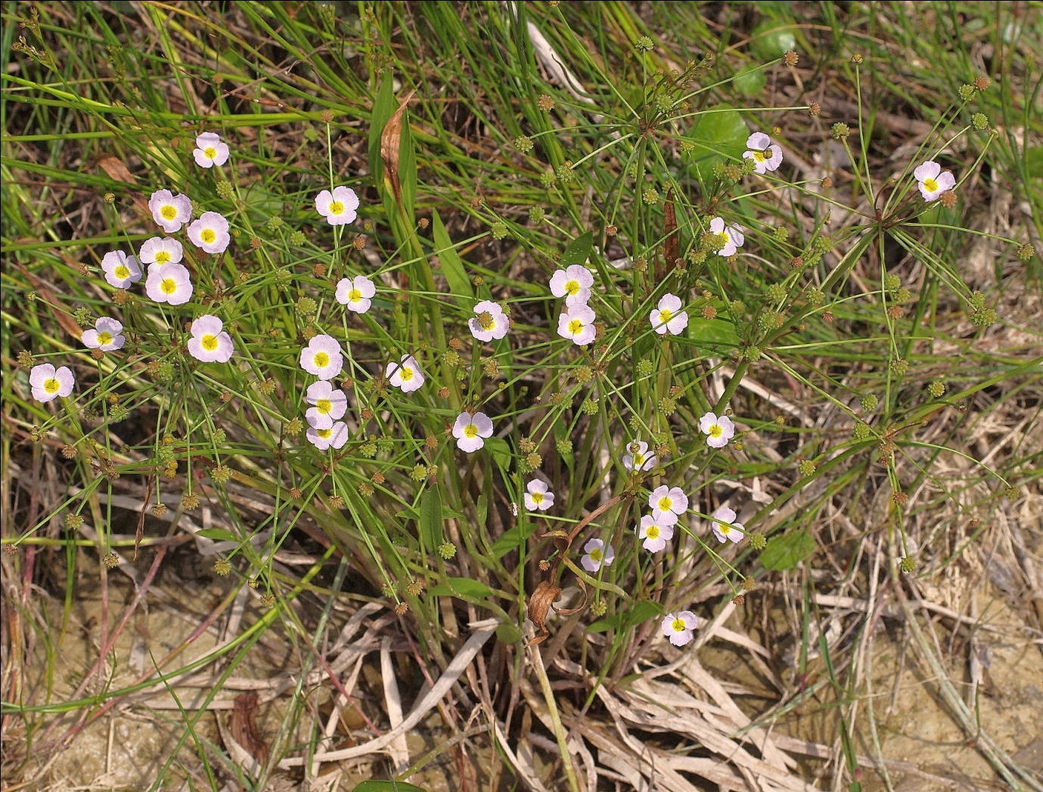
Lesser Water-plantain, Baldellia ranunculoides

GB status: Near Threatened. English status: Vulnerable

Lesser Water-plantain is an increasingly scarce plant of fluctuating water margins on calcareous substrates, growing in habitats where disturbance such as cattle grazing limits competition from taller vegetation. Its distribution in England has diminished by 43% (Stroh et al, 2014). In June 2017, around 150 flowering plants were present in Pond 3 and an adjoining shallow channel with a further 50 or so in the margins of Pond 5.
Tufted Sedge, Carex elata
English status: Near Threatened
This tussock-forming sedge is associated with fluctuating water margins in base-rich fens. Its British distribution is centred on the belt of former fenland extending from East Anglia to the Vale of York with outlying centres in the Lake District, the Cheshire Plain and Anglesey. Its range (Extent of Occupancy) in England contracted by 29% during the second half of the 20th century (Stroh et al, 2014). At Stow-cum-Quy Fen it grows locally at the margin of the main coprolite pit (Pond 5).
Water-violet Hottonia palustris
English status: Vulnerable
A widespread but local and declining plant in eastern England, the distribution (Area of Occupancy) of Water Violet declined by 33% in England during the latter part of the 20th century with a similar (37%) loss of range (Stroh et al, 2004). The Great Britain status of this species is also likely to be upgraded to Vulnerable in the near future. Water Violet was recorded from Ponds 2, 3 and 5 at Stow-cum-Quy Fen.
Marsh Pennywort, Hydrocotyle vulgaris
English status: Near Threatened
A humble plant of short vegetation in water margins and wet fens which, like many species of less fertile wetlands, is undergoing a long-term decline in distribution in England. It was recorded from Pond 3 and the bank of Pond 5.
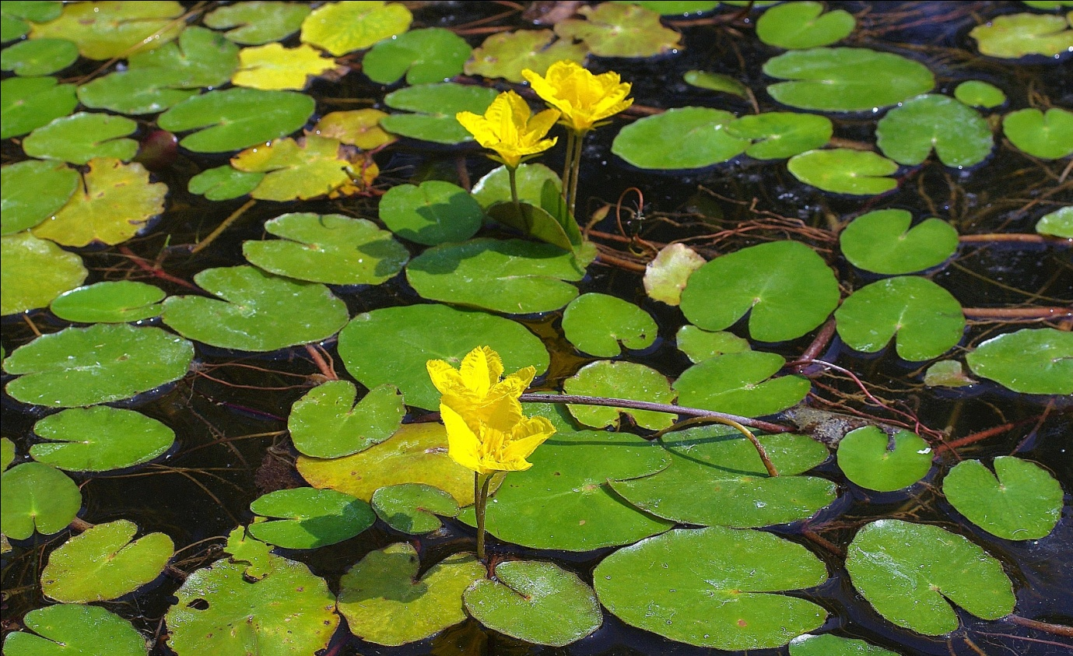
Fringed Water-lily Nymphoides peltata
GB status: Nationally Scarce
The native distribution of Fringed Water-lily is considered to be restricted to the Fens and the Thames basin (Preston et al, 2002). It is therefore considered to be Nationally Scarce. However, this species has been widely introduced elsewhere. Fringed Water-lily grows locally in the main coprolite pit (Pond 5) at Stow-cum-Quy Fen.
Fen Pondweed, Potamogeton coloratus
GB status: Nationally Scarce
This scarce, translucent pondweed is restricted to calcareous but oligotrophic still-waters. Its main centres are in East Anglia and Cambridgeshire, the Somerset Levels, Anglesey and the Hebridies. A small patch was found in Pond 7.
Lesser Spearwort, Ranunculus flammula
English status: Vulnerable
Although still widespread and locally frequent, Lesser Spearwort underwent a 32% decline in distribution in England during the latter half of the last century (Stroh et al, 2014). At Stow-cum-Quy Fen it was found in Ponds 3, 5 and 7.
5.2 Invertebrates
Peltodytes caesus (Haliplidae), an algivorous water beetle
GB: Nationally Scarce
This is a scarce beetle of base-rich ponds and ditches found in the coastal counties between Hampshire and the Wash, in the levels at either side of the Bristol Channel and inland in the Home Counties (Foster & Friday, 2011). It is rarely recorded in ditches in the Cambridgeshire Fens (Graham & Hammond, 2015) so it was surprising to encounter large numbers of adults in Pond 2 on both visits.
Enochrus nigritus (Hydrophilidae), a scavenger water beetle
GB status: Near Threatened
This small hydrophilid occurs amongst fen vegetation in shallow water margins. It has a very limited distribution in East Anglia, Cambridgeshire, the New Forest, Herefordshire and a handful of sites elsewhere in southern England and Wales. “It is mainly found in relict fens but also occasionally in recently created habitats in old fen areas” (Foster et al, in prep).
Enochrus nigritus was collected from Ponds 1, 3 and 6 on 17th May. As this species was only recognised as British in 1984, there are no previous records for Stow-cum-Quy Fen.
Enochrus quadripunctatus (Hydrophilidae), a scavenger water beetle
GB: Nationally Scarce
A mid-sized, brownish scavenger water beetle associated with clayey or silty water margins. Although older records are confused by taxonomic changes, the true E. quadripunctatus has a restricted British distribution strongly centred on the east of England; it appears to have extended its range in recent years (Foster et al, 2014).
On 17th May, E. quadripunctatus was found in two adjacent, unshaded cattle-grazed ponds (2 & 3). In the farmland at either side of the Ouse Washes, E. quadripunctatus occurs very locally in drains which are grazed and trampled by livestock (Graham & Hammond, 2015).
Limnebius papposus (Hydraenidae), a small water beetle
GB status: Near Threatened
This small beetle is restricted to richly-vegetated ponds and drains in lowland fenland areas. The Somerset Levels remain a stronghold but L. papposus shows evidence of serious decline in other parts of its range (Foster, 2010). During this survey, single female specimens were collected from Ponds 2 and 3. There are six previous records from Stow-cum-Quy Fen, dated between 1913 and 1965.
Donacia sparganii (Chrysomelidae), a reed beetle
GB status: Vulnerable
An adult was collected from a mass of Fringed Water-lily on the main coprolite pit (Pond 5) on 21st June, and others were seen. This species is associated with floating bur-reed leaves in moving water (Cox, 2007), though it has also been found on Flowering Rush; adults may feed on pollen, including that of water-lilies. It is tempting to speculate that the main pit at Stow-cum-Quy Fen provides an environment not dissimilar to a lowland river backwater, albeit lacking water movement.
Hubble (2014) summarised the status of D. sparganii as follows:
Previously widespread in southern England with scattered records as far north as southern Scotland. Following a large decline, now known only from a few widely scattered locations in southern England and south Wales. Prior to 1990 it was recorded in forty-six hectads; since 1990 it has been found in nine...making it appropriate for the Vulnerable category. The increased survey effort associated with publication of the Atlas (Cox, 2007) suggests the decline is real.
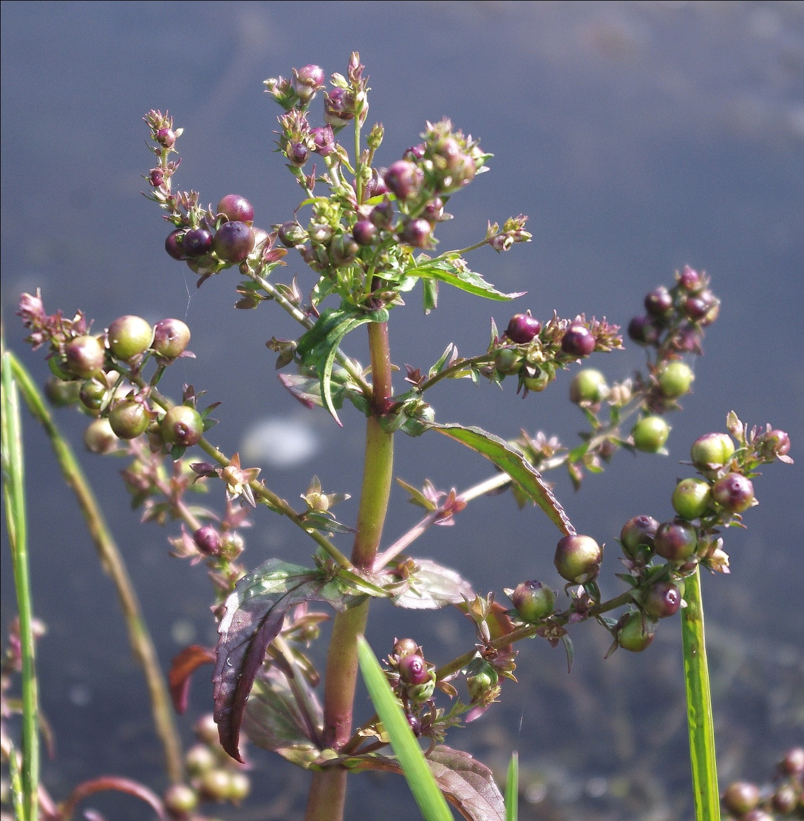
The national water beetle recording scheme dataset shows concentrations of records from the Somerset Levels and the River Nene in Cambridgeshire.
Gymnetron villosulum (Curculionidae), an aquatic weevil
GB status: Nationally Scarce
The larvae of this weevil form distinctive spherical galls in the ovaries of Pink Water-speedwell, in which they also pupate. Although still formally listed as Nationally Scarce, G. villosulum appears to be fairly frequent where its host plant is plentiful, primarily in the fluctuating margins of silty lowland ponds. It was detected in five out 175 farmland drains in the vicinity of the Ouse Washes in 2013-14 (Graham & Hammond, 2015).
Pelenomus canaliculatus (Curculionidae), an aquatic weevil
GB status: Nationally Scarce
This is one of a small group of fully aquatic weevils which feed on water-millfoils, though the collection of single specimens from Ponds 3 and 6 on 21st June is interesting since neither support Myriophyllum! Sampling of drains in the Cambridgeshire Fens suggests that another water-millfoil weevil, Eubrychius velutus, is fairly frequent (Kirby & Lambert, 2003; Graham & Hammond, 2015) but not P. canaliculatus. The species has a thinly scattered distribution across Britain but with no modern records from Scotland.
Comparison with historic water beetle records
The national recording scheme database shows that 95 water beetle species were recorded from Stow-cum-Quy Fen prior to the present survey (Appendix 2). Archival records span the period 1845 (Wollaston, 1845) to 1965, the main collectors being Professor F. Balfour-Browne during the period 1913 to 1919 and Professor G.N. Foster in 1964-65. Given the Fen’s proximity to Cambridge, it is surprising that there are no later records.
Forty of the species represented by archival records were found in May/June 2017 (42%) but 22 species apparently new for the site were also collected. This brings the Quy Fen water beetle list to 117 species. The ‘new’ species include some which have only been recognised as British species relatively recently, or are liable to be overlooked (e.g. various Helophorus species, Enochrus nigritus, E. quadripunctatus, Hydrobius rottenbergii and H. subrotundus, Cercyon sternalis). However, there are others which have genuinely increased during in recent decades such as Dytiscus circumflexus, Hydroglyphus geminus and Berosus affinis. No aquatic weevils were recorded previously but two were found in the current survey.
By contrast, many of the species not found since Balfour-Browne’s visits a century ago have seriously declined nationally (e.g. Haliplus variegatus, Dytiscus circumcinctus, Berosus luridus) or would once have been more widespread in Fenland (e.g. Noterus crassicornis, Hydaticus transversalis, Hydrophilus piceus). The reed-beetle Donacia aquatica, a Species of Principal Importance listed under Section 41 of the Natural Environment & Rural Communities Act, was found by C.E. Tottenham in 1906.
It therefore appears that there has been significant loss of rarer fenland water beetles from Stow-cum-Quy Fen during the past 100 years, though this may be a result of wider regional and national population declines rather than any dramatic deterioration in habitat quality within the site.
6. Priority Pond assessment
Priority Ponds are a habitat of principal importance as defined in Section 41 of the Natural Environment and Rural Communities Act 2006. All public authorities are obliged to consider the conservation of Habitats and Species of Principal Importance during the exercise of their duties. Priority ponds are considered to represent the best 20% of UK ponds in terms of nature conservation value. They are identified using a number of criteria. six of the nine ponds surveyed at Stow-cum-Quy Fen qualify as Priority Ponds, as summarised in Table 2.
Table 2: Priority Pond assessment for ponds at Spring Covert
Qualifying criterion | Pond 1 | Pond 2 | Pond 3 | Pond 4 | Pond 5 | Pond 6 | Pond 7 | Pond 8 | Pond 9
Ponds with species of high conservation importance (UKBAP/Section 41 species, fully protected species, Red List species); ponds with 1 Nationally Scarce plant or 3 or more NS aquatic invertebrates. |  | 3 NS water beetles | 2 NT + 2 NS water beetles |  | Donacia sparganii (Red List) |  | Water Vole
Ponds with exceptional populations or numbers of key species (>29 wetland vascular plants; >49 aquatic invertebrates) |  | 58 aquatic invertebrate taxa | 54 aquatic invertebrate taxa |  | 49 wetland plants & 60 aquatic invertebrates | 52 aquatic invertebrate taxa
Ponds of high ecological quality, classified as being of Good quality using PSYM. |  | ✔ | ✔ | ✔ | ✔ | ✔ | ✔

Ponds 1, 8 and 9 did not qualify, although Pond 1 was very close to the threshold for Good ecological quality.

7. References
Cambridgeshire Archaeology Field Group (2015). Wimpole coprolites. http://www.cafg.net/docs/articles/Wimpole%20coprolites.pdf
Environment Agency (2002). A guide to monitoring the ecological quality of ponds and canals using PSYM. Version 2. Environment Agency Midlands Region: Solihull.
Cox, M.L. (2007). Atlas of the seed and leaf beetles of Britain and Ireland. Pisces Publications: Newbury.

Foster, G.N (2010). A review of the scarce and threatened Coleoptera of Great Britain: 3, water beetles of Great Britain Joint Nature Conservation Committee: Peterborough.
Foster, G.N., Bilton, D.T., Hammond, M. & Nelson, B.H. (in prep.) Atlas of the Hydrophiloid beetles of Britain and Ireland. Centre for Ecology and Hydrology.

Graham, J. & Hammond, M. (2015). Investigating ditch biodiversity and management practises in the arable landscape of the Ouse Washes Landscape Partnership Area: a survey of vegetation and aquatic Coleoptera. Report to the Ouse Washes Landscape Partnership Scheme.
Hubble, D. (2014). A review of the scarce and threatened beetles of Great Britain: the leaf beetles and their allies - Chrysomelidae, Megalopodidae and Orsodacnidae. Natural England Commissioned Repot NECR161. Natural England.
John, D.M., Whitton, B.A, & Brook, A.J. (2002). The freshwater algal flora of the British Isles. Cambridge University Press: Cambridge.
Kirby, P. & Lambert, S. (2003). Fenland farm ditch survey – summary document. Unpublished report to Cambridgeshire Biodiversity Partnership.
Leach, S.J. & Rusbridge, D.J. (2006). A tool for assessing the current conservation status of vascular plants on SSSIs in England. English Nature Research Report 690. English Nature: Peterborough.

O’Connor, B. (2001). The origins and development of the British coprolite industry. Mining History, 14 (5): 46-57.
O’Connor, B. (2011). The fossil diggings on Quy Fen. Private publication.
Preston, C.D., Pearman, D.A. & Dines, T.D. (2002). New Atlas of the British & Irish flora. Oxford University Press: Oxford.
Stewart, N. (2013). Revised threat status of UK red list stoneworts. JNCC (http://www.jncc.gov.uk/species/plants).
Stroh, P.A. , Leach, S.J. , August, T.A., Walker, K.J., Pearman, D.A., Rumsey, F.J., Harrower, C.A. Fay, M.F., Martin, J.P., Pankhurst, T., Preston, C.D. & Taylor, I. (2014). A vascular plant Red List for England. Botanical Society of Britain and Ireland: Bristol.
Wollaston, T.V. (1845). Captures in the Cambridge Fens. The Zoologist, 3: 1016.

Appendix 1: PSYM data
Site details
Site name | QUY FEN POND 1 | QUY FEN POND 2 | QUY FEN POND 3 | QUY FEN POND 4 | QUY FEN POND 5 | QUY FEN POND 6 | QUY FEN POND 7 | QUY FEN POND 8
Survey date | 17-May-17 | 17-May-17 | 17-May-17 | 17-May-17 | 17-May-17 | 17-May-17 | 17-May-17 | 17-May-17
Grid reference (e.g. SP123456 or higher precision) | TL  511628 | TL  512627 | TL 512627 | TL  513624 | TL 514626 | TL  514627 | TL  516627 | TL  514629
Plant metrics
No. of submerged + marginal plant species (not including floating leaved) | 9 | 27 | 26 | 4 | 39 | 17 | 24 | 2
Number of uncommon plant species | 2 | 10 | 8 | 3 | 16 | 4 | 9 | 0
Trophic Ranking Score (TRS) | 8.26 | 9.16 | 8.22 | 7.3 | 9.01 | 8.93 | 8 | 8.65
Invertebrates metrics
ASPT | 4.85 | 5.19 | 4.90 | 5.5 | 4.86 | 5.21 | 5.67 | 3.75
Odonata + Megaloptera (OM) families | 2 | 3 | 2 | 2 | 3 | 2 | 3 | 0
Coleoptera families | 5 | 5 | 5 | 3 | 5 | 3 | 4 | 1
Environmental variables
Altitude (m) | 4 | 4 | 4 | 4 | 4 | 4 | 4 | 4
Easting | 5516 | 5512 | 5512 | 5513 | 5514 | 5514 | 5516 | 5514
Northing | 2628 | 2627 | 2627 | 2624 | 2626 | 2627 | 2627 | 2629
Shade (%) | 30 | 0 | 2 | 0 | 5 | 15 | 10 | 70
Inflow (0/1) | 0 | 0 | 0 | 0 | 0 | 0 | 0 | 0
Grazing (%) | 0 | 100 | 100 | 0 | 50 | 0 | 0 | 0
pH | 7.3 | 7.6 | 7.3 | 8.4 | 7.6 | 7.9 | 7.9 | 7.6
Emergent plant cover (%) | 20 | 20 | 65 | 0 | 15 | 10 | 17 | 30
Base clay (1-3) | 3 | 3 | 3 | 3 | 3 | 3 | 3 | 3
Base sand, gravel, cobbles (1-3) | 1 | 1 | 1 | 1 | 1 | 1 | 1 | 1
Base peat (1-3) | 1 | 1 | 1 | 1 | 1 | 1 | 1 | 1
Base rock (1-3) | 1 | 1 | 1 | 1 | 1 | 1 | 1 | 1
Area (m2) | 1634 | 600 | 240 | 320 | 3700 | 230 | 360 | 1902
Results
Submerged + marginal plant species
Predicted (SM) | 23.7 | 19.0 | 16.2 | 16.8 | 26.7 | 16.1 | 17.4 | 24.9
Actual (SM) | 9 | 27 | 26 | 4 | 39 | 17 | 24 | 2
EQI (SM) | 0.38 | 1.42 | 1.61 | 0.24 | 1.46 | 1.06 | 1.38 | 0.08
IBI (SM) | 1 | 3 | 3 | 0 | 3 | 3 | 3 | 0
Uncommon plant species
Predicted (U) | 4.1 | 3.1 | 2.7 | 2.7 | 4.4 | 2.7 | 2.9 | 4.4
Actual (U) | 2 | 10 | 8 | 3 | 16 | 4 | 9 | 0
EQI (U) | 0.49 | 3.19 | 2.96 | 1.10 | 3.60 | 1.48 | 3.11 | 0.00
IBI (U) | 1 | 3 | 3 | 3 | 3 | 3 | 3 | 0
Trophic Ranking Score (TRS)
Predicted (TRS) | 8.74 | 8.72 | 8.68 | 8.76 | 8.74 | 8.73 | 8.73 | 8.77
Actual (TRS) | 8.26 | 9.16 | 8.22 | 7.30 | 9.01 | 8.93 | 8.00 | 8.65
EQI (TRS) | 0.95 | 1.05 | 0.95 | 0.83 | 1.03 | 1.02 | 0.92 | 0.99
IBI (TRS) | 3 | 2 | 3 | 3 | 3 | 3 | 3 | 3
ASPT
Predicted (ASPT) | 5.11 | 5.07 | 5.10 | 5.08 | 5.11 | 5.09 | 5.09 | 5.11
Actual (ASPT) | 4.85 | 5.19 | 4.90 | 5.50 | 4.86 | 5.21 | 5.67 | 3.75
EQI (ASPT) | 0.95 | 1.02 | 0.96 | 1.08 | 0.95 | 1.03 | 1.11 | 0.73
IBI (ASPT) | 3 | 3 | 3 | 3 | 3 | 3 | 3 | 2
Odonata + Megaloptera (OM) families
Predicted (OM) | 3.24 | 3.20 | 3.43 | 3.07 | 3.12 | 3.21 | 3.16 | 3.45
Actual (OM) | 2 | 3 | 2 | 2 | 3 | 2 | 3 | 0
EQI (OM) | 0.62 | 0.94 | 0.58 | 0.65 | 0.96 | 0.62 | 0.95 | 0.00
IBI (OM) | 2 | 3 | 2 | 2 | 3 | 2 | 3 | 0
Coleoptera families
Predicted (CO) | 3.77 | 3.73 | 3.74 | 3.74 | 3.77 | 3.74 | 3.75 | 3.76
Actual (CO) | 5 | 5 | 5 | 3 | 5 | 3 | 4 | 1
EQI (CO) | 1.33 | 1.34 | 1.34 | 0.80 | 1.33 | 0.80 | 1.07 | 0.27
IBI (CO) | 3 | 3 | 3 | 3 | 3 | 3 | 3 | 1
Sum of Individual Metrics | 13 | 17 | 17 | 14 | 18 | 17 | 18 | 6
Index of Biotic Integrity (%) | 72% | 94% | 94% | 78% | 100% | 94% | 100% | 33%
PSYM quality category (IBI >75%=Good, 51-75%= Moderate, 25-50%=Poor, <25%=V Poor) | Moderate | Good | Good | Good | Good | Good | Good | Poor
Is this a Priority Pond? (Good quality category) | No | Yes | Yes | Yes | Yes | Yes | Yes | No

Appendix 2: Wetland plants recorded during the survey
Species | English name
Agrostis stolonifera | Creeping Bent
Alisma lanceolatum | Narrow-leaved Water-plantain
Alisma plantago-aquatica | Common Water-plantain
Alopecurus aequalis | Orange Foxtail
Apium nodiflorum | Fool's Water-cress
Baldellia ranunculoides | Lesser Water-plantain
Berula erecta | Lesser Water-parsnip
Butomus umbellatus | Flowering Rush
Calliergonella cuspidata | Pointed Spear-moss
Callitriche platycarpa | Various-leaved Water-starwort
Cardamine pratensis | Lady's Smock
Carex disticha | Brown Sedge
Carex elata | Tufted Sedge
Carex flacca | Glaucous Sedge
Carex otrubae | False Fox Sedge
Carex panicea | Carnation Sedge
Carex riparia | Greater Pond Sedge
Ceratophyllum submersum | Soft Hornwort
Chara hispida | Prickly Stonewort
Chara vulgaris | Common Stonewort
Deschampsia cespitosa | Tufted Hair-grass
Drepanocladus aduncus | Kneiff's Hook-moss
Eleocharis palustris | Common Spike-rush
Elodea nuttallii | Nuttall's Waterweed
Epilobium hirsutum | Greater Willowherb
Epilobium parviflorum | Lesser Hairy Willowherb
Epilobium tetragonum | Square-stemmed Willowherb
Eupatorium cannabinum | Hemp Agrimony
Fontinalis antipyretica | Greater Water-moss
Galium palustre ssp. elongatum | Greater Marsh Bedstraw
Glyceria fluitans | Flote-grass
Hippuris vulgaris | Mare's-tail
Hottonia palustris | Water Violet
Hydrocotyle vulgaris | Marsh Pennywort
Juncus articulatus | Jointed Rush
Juncus inflexus | Hard Rush
Juncus subnodulosus | Blunt-flowered Rush
Lemna triscula | Ivy-leaved Duckweed
Leptodictyum riparium | Kneiff's Feather-moss
Lycopus europaeus | Gipsywort
Lysimachia vulgaris | Yellow Loosestrife
Lythrum salicaria | Purple Loosestrife
Mentha aquatica | Water Mint
Myosotis laxa ssp. caespitosa | Tufted Forget-me-not
Myosotis scorpioides | Water Forget-me-not
Myriophyllum spicatum | Spiked Water-millfoil
Nasturtium officinale s.l. | Water-cress
Nymphaea alba | White Water-lily
Nymphaea marliacea | Pink Water-lily
Nymphoides peltata | Fringed Water-lily
Persicaria amphibia | Amphibious Bistort
Phalaris arundinacea | Reed Canary-grass
Phragmites australis | Common Reed
Pohlia wahlenbergia var. wahlenbergia | Pale Glaucous Thread-moss
Potamogeton coloratus | Fen Pondweed
Potamogeton crispus | Curled Pondweed
Potamogeton natans | Broad-leaved Pondweed
Ranunculus flammula | Lesser Spearwort
Ranunculus sceleratus | Celery-leaved Buttercup
Ranunculus trichophyllus | Thread-leaved Water-crowfoot
Samolus valerandi | Brookweed
Schoenoplectus lacustris | Common Club-rush
Scrophularia auriculata | Water Figwort
Scutellaria galericulata | Skullcap
Solanum dulcamara | Woody Nightshade
Sparganium erectum | Branched Bur-reed
Stachys palustris | Marsh Woundwort
Symphytum officinale | Comfrey
Thalictrum flavum | Meadow-rue
Tolypella glomerata | Clustered Stonewort
Typha angustifolia | Lesser Reedmace
Typha latifolia | Greater Reedmace
Veronica catenata | Pink Water-speedwell
Zannichellia palustris | Horned Pondweed

Appendix 3: Aquatic macro-invertebrates recorded during the survey
Taxon | English name | Family | Order | GB Status
Crangonyx pseudogracilis | an amphipod shrimp | Crangonyctidae | Amphipoda | Common
Gammarus pulex | Freshwater Shrimp | Gammaridae | Amphipoda | Common
Musculium lacustre | Capped Orb Mussel | Sphaeriidae | Bivalvia | Common
Pisidium sp. | a pea-mussel | Sphaeriidae | Bivalvia
Haemopis sanguisuga | Horse Leech | Haemopidae | Hirudinea | Common
Theromyzon tessulatum | Duck Leech | Glossiphonidae | Hirudinea | Common
Erpobdella octoculata | a leech | Erpobdellidae | Hirudinea | Common
Donacia sparganii | a reed beetle | Chrysomelidae | Coleoptera | Vulnerable
Gymnetron villosulum | Pink Water-speedwell Weevil | Curculionidae | Coleoptera | NS
Pelenomus canaliculatus | an aquatic weevil | Curculionidae | Coleoptera | NS
Dryops luridus | a long-toed water beetle | Dryopidae | Coleoptera | Common
Dryops sp. (other) | a long-toed water beetle | Dryopidae | Coleoptera
Acilius sulcatus | a diving beetle | Dytiscidae | Coleoptera | Local
Agabus bipustulatus | a diving beetle | Dytiscidae | Coleoptera | Common
Agabus nebulosus | a diving beetle | Dytiscidae | Coleoptera | Common
Colymbetes fuscus | a diving beetle | Dytiscidae | Coleoptera | Common
Dytiscus circumflexus | a great diving beetle | Dytiscidae | Coleoptera | Local
Dytiscus marginalis | Great Diving Beetle | Dytiscidae | Coleoptera | Common
Dytiscus semisulcatus | Great Diving Beetle | Dytiscidae | Coleoptera | Common
Hydroglyphus geminus | a diving beetle | Dytiscidae | Coleoptera | Local
Hydroporus angustatus | a diving beetle | Dytiscidae | Coleoptera | Common
Hydroporus palustris | a diving beetle | Dytiscidae | Coleoptera | Common
Hydroporus planus | a diving beetle | Dytiscidae | Coleoptera | Common
Hygrotus confluens | a diving beetle | Dytiscidae | Coleoptera | Common
Hygrotus impressopunctatus | a diving beetle | Dytiscidae | Coleoptera | Common
Hygrotus inaequalis | a diving beetle | Dytiscidae | Coleoptera | Common
Hygrotus versicolor | a diving beetle | Dytiscidae | Coleoptera | Local
Hyphydrus ovatus | a diving beetle | Dytiscidae | Coleoptera | Common
Ilybius ater | a diving beetle | Dytiscidae | Coleoptera | Common
Ilybius fuliginosus | a diving beetle | Dytiscidae | Coleoptera | Common
Ilybius quadriguttatus | a diving beetle | Dytiscidae | Coleoptera | Common
Laccophilus minutus | a diving beetle | Dytiscidae | Coleoptera | Common
Liopterus haemorrhoidalis | a diving beetle | Dytiscidae | Coleoptera | Local
Rhantus grapii | a diving beetle | Dytiscidae | Coleoptera | Local
Rhantus suturalis | a diving beetle | Dytiscidae | Coleoptera | Local
Gyrinus substriatus | Common Whirligig | Gyrinidae | Coleoptera | Common
Haliplus confinis | an algivorous water beetle | Haliplidae | Coleoptera | Local
Haliplus flavicollis | an algivorous water beetle | Haliplidae | Coleoptera | Local
Haliplus fluviatilis | an algivorous water beetle | Haliplidae | Coleoptera | Common
Haliplus immaculatus | an algivorous water beetle | Haliplidae | Coleoptera | Common
Haliplus lineatocollis | an algivorous water beetle | Haliplidae | Coleoptera | Common
Haliplus obliquus | an algivorous water beetle | Haliplidae | Coleoptera | Local
Haliplus ruficollis | an algivorous water beetle | Haliplidae | Coleoptera | Common
Peltodytes caesus | an algivorous water beetle | Haliplidae | Coleoptera | NS
Helophorus aequalis | a scavenger water beetle | Helophoridae | Coleoptera | Common
Helophorus brevipalpis | a scavenger water beetle | Helophoridae | Coleoptera | Common
Helophorus grandis | a scavenger water beetle | Helophoridae | Coleoptera | Common
Helophorus griseus | a scavenger water beetle | Helophoridae | Coleoptera | Local
Helophorus minutus | a scavenger water beetle | Helophoridae | Coleoptera | Common
Helophorus obscurus | a scavenger water beetle | Helophoridae | Coleoptera | Common
Limnebius papposus | a small water beetle | Hydraenidae | Coleoptera | NT
Ochthebius dilatatus | a small water beetle | Hydraenidae | Coleoptera | Local
Ochthebius minimus | a small water beetle | Hydraenidae | Coleoptera | Common
Anacaena bipustulata | a scavenger water beetle | Hydrophilidae | Coleoptera | Local
Anacaena limbata | a scavenger water beetle | Hydrophilidae | Coleoptera | Common
Berosus affinis | a scavenger water beetle | Hydrophilidae | Coleoptera | Local
Cercyon sternalis | a scavenger water beetle | Hydrophilidae | Coleoptera | Local
Coelostoma orbiculare | a scavenger water beetle | Hydrophilidae | Coleoptera | Local
Cymbiodyta marginella | a scavenger water beetle | Hydrophilidae | Coleoptera | Local
Enochrus coarctatus | a scavenger water beetle | Hydrophilidae | Coleoptera | Local
Enochrus nigritus | a scavenger water beetle | Hydrophilidae | Coleoptera | NT
Enochrus quadripunctatus | a scavenger water beetle | Hydrophilidae | Coleoptera | NS
Enochrus testaceus | a scavenger water beetle | Hydrophilidae | Coleoptera | Common
Helochares lividus | a scavenger water beetle | Hydrophilidae | Coleoptera | Local
Hydrobius fuscipes | a scavenger water beetle | Hydrophilidae | Coleoptera | Common
Hydrobius rottenbergii | a scavenger water beetle | Hydrophilidae | Coleoptera | Local
Hydrobius subrotundus | a scavenger water beetle | Hydrophilidae | Coleoptera | Local
Laccobius bipunctatus | a scavenger water beetle | Hydrophilidae | Coleoptera | Common
Noterus clavicornis | a burrowing water beetle | Noteridae | Coleoptera | Common
Scirtidae indet | marsh beetle larvae | Scirtidae | Coleoptera
Chaoboridae indet | phantom midge larvae | Chaoboridae | Diptera
Chironomidae | non-biting midge larvae | Chironomidae | Diptera
Culicidae | mosquito larvae | Culicidae | Diptera
Dixidae | meniscus midge larvae | Dixidae | Diptera
Eristalini | hoverfly larvae | Syrphidae | Diptera
Odontomyia tigrina | Black Colonel | Stratiomyidae | Diptera | Local
Oplodontha viridula | Common Green Colonel | Stratiomyidae | Diptera | Local
Oxycera sp. 1 | a soldier-fly | Stratiomyidae | Diptera
Oxycera sp. 2 | a soldier-fly | Stratiomyidae | Diptera
Cloeon dipterum | Pond Olive mayfly | Baetidae | Ephemeroptera | Common
Bithynia tentaculata | Common Bithynia | Bithyniidae | Gastropoda | Common
Lymnaea stagnalis | Great Pond Snail | Lymnaeidae | Gastropoda | Common
Radix balthica | Wandering Snail | Lymnaeidae | Gastropoda | Common
Stagnicola palustris agg. | Marsh Pond Snail | Lymnaeidae | Gastropoda | Common
Physa fontinalis | Common Bladder Snail | Physidae | Gastropoda | Common
Anisus leucostoma | White-lipped Ramshorn | Planorbidae | Gastropoda | Common
Anisus vortex | Whirlpool Ramshorn | Planorbidae | Gastropoda | Common
Bathyomphalus contortus | Twisted Ramshorn | Planorbidae | Gastropoda | Common
Gyraulus crista | Nautilus Ramshorn | Planorbidae | Gastropoda | Common
Hippeutis complanatus | Flat Ramshorn | Planorbidae | Gastropoda | Local
Planorbis planorbis | Margined Ramshorn | Planorbidae | Gastropoda | Common
Potamopyrgus antipodarum | Jenkin's Spire-snail | Hydrobiidae | Gastropoda | Common
Corixa punctata | lesser water-boatmen | Corixidae | Hemiptera | Common
Hesperocorixa linnaei | a lesser water-boatmen | Corixidae | Hemiptera | Common
Hesperocorixa sahlbergi | a lesser water-boatmen | Corixidae | Hemiptera | Common
Micronecta scholtzii | a water-singer | Corixidae | Hemiptera | Local
Sigara dorsalis | a lesser water-boatman | Corixidae | Hemiptera | Common
Sigara fossarum | a lesser water-boatman | Corixidae | Hemiptera | Common
Sigara lateralis | a lesser water-boatman | Corixidae | Hemiptera | Common
Gerris lacustris | Common Pond-skater | Gerridae | Hemiptera | Common
Gerris odontogaster | Toothed Pond-skater | Gerridae | Hemiptera | Common
Gerris thoracicus | a pond-skater | Gerridae | Hemiptera | Common
Hydrometra stagnorum | Water Measurer | Hydrometridae | Hemiptera | Common
Mesovelia furcata | Pondweed Bug | Mesoveliidae | Hemiptera | Local
Ilyocoris cimicoides | Saucer Bug | Naucoridae | Hemiptera | Local
Nepa cinerea | Water Scorpion | Nepidae | Hemiptera | Common
Ranatra linearis | Water Stick-insect | Nepidae | Hemiptera | Local
Notonecta glauca | Common Backswimmer | Notonectidae | Hemiptera | Common
Plea minutissima | Pygmy Backswimmer | Pleidae | Hemiptera | Common
Microvelia reticulata | a pygmy water-cricket | Velidae | Hemiptera | Common
Asellus aquaticus | Water Hoglouse | Asellidae | Isopoda | Common
Sialis lutaria | Common Alderfly | Sialidae | Megaloptera | Common
Aeshna grandis | Brown Hawker | Aeshnidae | Odonata | Common
Anax imperator | Emperor Dragonfly | Aeshnidae | Odonata | Local
Brachytron pratense | Hairy Dragonfly | Aeshnidae | Odonata | Local
Coenagrion puella | Azure Damselfly | Coenagrionidae | Odonata | Common
Enallagma cyathigerum | Common Blue Damselfly | Coenagrionidae | Odonata | Common
Ischnura elegans | Blue-tailed Damselfly | Coenagrionidae | Odonata | Common
Lestes sponsa | Emerald Damselfly | Lestidae | Odonata | Common
Libellula depressa | Broad-bodied Chaser | Libellulidae | Odonata | Local
Libellula quadrimaculata | Four-spotted Chaser | Libellulidae | Odonata | Common
Orthetrum cancellatum | Black-tailed Skimmer | Libellulidae | Odonata | Local
Sympetrum striolatum | Common Darter | Libellulidae | Odonata | Common
Athripsodes aterrimus | a caddis-fly | Leptoceridae | Trichoptera | Common
Glyphotaelius pellucidus | a caddis-fly | Limnephilidae | Trichoptera | Common
Limnephilus affinis | a caddis-fly | Limnephilidae | Trichoptera | Common
Limnephilus sp. (other) | a caddis-fly | Limnephilidae | Trichoptera
Limnephilus stigma | a caddis-fly | Limnephilidae | Trichoptera | Common
Phryganeidae early instar larva | a caddis-fly | Phryganeidae | Trichoptera
Tricladida indet | a flatworm | Tricladida | Tricladida

Appendix 4: archival water beetle records for Quy Fen
(courtesy of the Balfour-Browne Club and Aquatic Coleoptera Conservation Trust)
Species | Dates | Recorders | 2017?
Acilius sulcatus | 1918, 1965 | FBB, GNF | ✓
Agabus bipustulatus | 1964 | GNF | ✓
Agabus didymus | 1925 | FBB
Agabus nebulosus | 1965 | GNF | ✓
Agabus paludosus | 1964 | ACW
Agabus sturmii | 1918 | FBB
Agabus unguicularis | 1918 | FBB
Anacaena bipustulata | 1918-19 | FBB | ✓
Anacaena globulus | 1913 | FBB
Berosus luridus | 1913, 1918 | FBB
Berosus signaticollis | -1908, 1918 | JAP, FBB
Brychius elevatus | 1965 | GNF
Chaetarthria seminulum sensu lato | 1918 | FBB
Hygrotus impressopunctatus | 1918 | FBB | ✓
Coelostoma orbiculare | 1918 | FBB | ✓
Colymbetes fuscus | 1918 | FBB | ✓
Liopterus haemorrhoidalis | 1918 | FBB | ✓
Cymbiodyta marginellus | 1913 | FBB | ✓
Donacia aquatica | 1906 | CET
Dytiscus circumcinctus | 1918-19 | FBB
Dytiscus semisulcatus | 1913 | FBB | ✓
Enochrus coarctatus | 1918 | FBB | ✓
Enochrus melanocephalus | 1918 | FBB
Enochrus ochropterus | 1913 | FBB
Enochrus testaceus | 1964 | GNF | ✓
Graptodytes granularis | -1908, 1918 | JAP, FBB
Graptodytes pictus | 1913 | FBB
Gyrinus marinus | 1965 | GNF
Gyrinus paykulli | 1920, 1925, 1943 | EJP, THB, CET
Gyrinus substriatus | 1943 | CET | ✓
Haliplus confinis | 1913, 1918 | FBB | ✓
Haliplus flavicollis | 1918 | FBB | ✓
Haliplus fluviatilis | 1965-65 | GNF | ✓
Haliplus fulvus | 1918 | FBB
Haliplus heydeni | 1918 | FBB
Haliplus immaculatus | 1919 | FBB | ✓
Haliplus laminatus | 1964 | GNF
Haliplus lineatocollis | 1943 | CET | ✓
Haliplus obliquus | 1965 | GNF | ✓
Haliplus ruficollis | 1913, 1919 | FBB | ✓
Haliplus variegatus | 1918-19 | FBB
Haliplus sibiricus | 1918 | FBB
Helochares lividus | 1918 | FBB | ✓
Helophorus brevipalpis | 1913 | FBB | ✓
Hydaticus seminiger | 1845 | TVW
Hydaticus transversalis | 1845, 1918 | TVW, FBB
Hydraena riparia | 1918 | FBB
Hydrobius fuscipes sensu lato | 1919 | FBB | ✓
Hydrophilus piceus | 1918 | FBB
Hydroporus angustatus | 1918 | FBB | ✓
Hydroporus erythrocephalus | 1913, 1921 | FBB, EJP
Hydroporus memnonius | 1918 | FBB
Hydroporus nigrita | 1913 | FBB
Hydroporus palustris | 1913 | FBB | ✓
Hydroporus planus | 1964 | GNF | ✓
Hydroporus pubescens | 1913, 1918, 1965 | FBB, GNF
Hydroporus striola | 1913, 1918 | FBB
Hydroporus tessellatus | 1918, 1965 | FBB, GNF | ✓
Hydroporus tristis | 1919 | FBB
Hygrobia hermanni | 1943 | CET
Hygrotus inaequalis | 1964 | GNF | ✓
Hygrotus versicolor | 1918 | FBB | ✓
Hyphydrus ovatus | 1964 | GNF | ✓
Ilybius ater | 1913 | FBB | ✓
Ilybius fenestratus | 1964 | FBB
Ilybius fuliginosus | 1918 | FBB | ✓
Ilybius quadriguttatus | 1965 | GNF | ✓
Ilybius subaeneus | 1918, 1964-65 | FBB, GNF
Laccobius ytenensis | 1965 | GNF
Laccobius colon | 1919 | FBB
Laccobius bipunctatus | 1965 | ACW | ✓
Laccobius minutus | 1919 | FBB
Laccobius sinuatus | 1964 | GNF
Laccobius striatulus | 1965 | GNF
Laccophilus hyalinus | 1918 | FBB
Laccophilus minutus | 1918 | FBB | ✓
Laccornis oblongus | 1918 | FBB
Limnebius nitidus | 1965 | GNF.
Limnebius papposus | 1913-1965 | FBB, GNF | ✓
Limnebius truncatellus | 1919 | FBB
Nebrioporus elegans | 1964 | GNF
Noterus clavicornis | 1913 | FBB | ✓
Noterus crassicornis | 1845, 1918-19 | TVW, FBB
Ochthebius minimus | 1913, 1918 | FBB | ✓
Platambus maculatus | 1925, 1965 | FBB, GNF
Porhydrus lineatus | -1937 | TTM
Nebrioporus assimilis | 1925 | FBB
Rhantus exsoletus | 1918, 1964=65 | FBB, GNF
Rhantus grapii | 1891, 1913. 1918 | DS, FBB | ✓
Rhantus suturalis | 1918 | FBB | ✓
Scarodytes halensis | 1925, 1964-65 | FBB, GNF
Sphaerius acaroides | -1900
Stictonectes lepidus | 1918 | FBB
Stictotarsus duodecimpustulatus | 1918 | FBB
Hydroporus dorsalis sensu lato | 1964 | GNF
FBB = Professor F. Balfour-Browne, THB = Sir T.H. Beare, GNF = Professor G.N. Foster, TTM = Dr T.T. Macan, EJP = Rev E.J. Pearce, JAP = Dr J.A. Power, DS = Dr D. Sharp, CET = Rev C.E. Tottenham, ACW = Dr A.C. Warne, TVW = T.V. Wollaston

As no alderflies were recorded in the survey, this metric is referred to simply as diversity of Odonata families.
Wetland vascular plants are those listed on the PSYM/National Pond Survey pro-forma
Conservation status of charophytes is taken from Stewart (2013)
England conservation status for vascular plants is based on Stroh et al (2014).
BSBI News no 135, p59.
GB rarity status for vascular plants is based on Leach & Rusbridge (2006).
Status designations for water beetles were reviewed by Foster (2010), with the exception of the reed-beetles of the Donaciinae, which were reviewed by Hubble (2014), and weevils, which were last reviewed by Hyman (1992)
See http://freshwaterhabitats.org.uk/projects/pond-hap/priority-pond-criteria/
It is assumed that since Near Threatened species have a higher conservation status than Nationally Scarce species, they also count towards this criterion.

